**Binomial Option Pricing Model**

**Single Period Binomial Trees**

# Single period Binomial Trees

* Consider **two possible ways** that the current stock price can move – **Up & Down**
* 

$S_u = S_0 \cdot u$

$S_d = S_0 \cdot d$





* Note that the Up and Down **naming is used loosely** here
  + Up **does not necessarily mean the resulting price is higher than the initial**; vice-versa for Down
  + They represent the resulting prices **relative to each other**

$\therefore S_u > S_d \equiv u > d$



* Since **only two possibilities** are considered (“Binomial”), we can easily represent them **using branches** (“Tree”), hence the name “Binomial Trees”
* We can use Binomial Trees to price (European) options using **one of two methods**:
  + Replicating Portfolio
  + Risk-Neutral Valuation

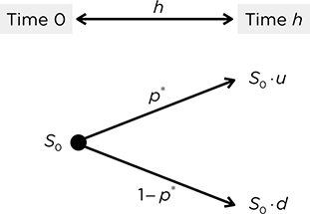

## Forward (Standard) Binomial Tree

* 
* Suppose the stock price **grows at the risk-free rate (Less any dividends)**
* However, the growth this way is not guaranteed – there is **some risk involved**
* We account for this risk by multiplying the growth factor by the **standard deviation**
  + The **up factor** should have a **higher growth** thus **adds the SD over the period**
  + The **down factor** should have a **lower growth** thus **subtracts the SD over the period**
* Known as a Forward Binomial Tree because if the **SD is 0**, the **future stock price becomes the forward price**
* Note that we can only use this method if it was explicitly stated that it is a **Forward Tree**

$u = e^{(r-q)t + \sigma\sqrt{t}}$

$d = e^{(r-q)t - \sigma\sqrt{t}}$





* 
* 

$$u = \frac{S_u}{S_0}$$

$$d = \frac{S_d}{S_0}$$





## Understanding the Forward Tree

* As the name suggests, it is a Binomial Tree which has a **Forward as the underlying**
* The price of the forward can either increase or decrease each period, based on its standard deviation

$$u_F = e^{\sigma\sqrt{t}}$$

$$u_D = e^{-\sigma\sqrt{t}}$$





* Thus, in the following period we will have the following prices:

$$F_U = F_0 \cdot e^{\sigma\sqrt{t}}$$

$$F_D = f_0 \cdot e^{-\sigma\sqrt{t}}$$





* We assume that the Forward is fairly priced, thus we obtain

$$F_U = S_0 \cdot e^{(r-q)t + \sigma\sqrt{t}} = S_0 \cdot d$$

$$F_D = S_0 \cdot e^{(r-q)t - \sigma\sqrt{t}} = S_0 \cdot u$$





# Replicating Portfolio Method

* Based on the **law of one price**, portfolios with the same payoffs must have the same initial cashflows to **avoid arbitrage**
* Thus, if we form a **portfolio of Stocks and Bonds that replicate the payoffs of a particular option** under BOTH scenarios of the binomial tree, the cost of entering the portfolio is the **cost of that option**
* 
* 

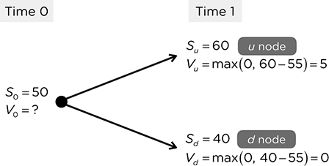

We assume that **dividends are continuous**, and **all dividends are reinvested**:\

$$\Delta e^{qt} \cdot S_0 u + Be^{rt} = V_u $$

$$\Delta e^{qt} \cdot S_0 d + Be&{rt} = V_d$$





Subtracting the Down from Up scenario,

$$\Delta e^{qt} \cdot S_0 u – Be^{qt} \cdot S_0 d = V_u – V_d$$

$$\Delta e&{qt}S_0(u-d) = V_u – V_d$$







Substituting it back,

$$e^{-qt} \cdot \frac{V_u – V_d}{S_0(u -d)} \cdot e^{\delta t}S_0 u + Be^{rt} = V_u$$

$$\frac{V_u – V_d}{u - d} \cdot u + Be^{rt} = V_u$$

$$Be^{rt} = V_u – u \cdot \frac{V_u – V_d}{u - d}$$

$$Be^{rt} = \frac{uV_u – dV_u – uV_u + uV_d}{u - d}$$

$$Be^{rt} = \frac{uV_d – dV_u}{u - d}$$

$$B = e^{rt} \cdot \frac{uV_d – dV_u}{u - d}$$













Note that the Price of the Option is also known as the **Value of the Option,**

$$\therefore V_0 = \Delta \cdot S_0 + B$$



calls 
= ASo—B0 
Buy Shares & Sell Bonds (Borrow) 
Puts 
% = -ASO + Bo 
Sell Shares & Buy Bonds (Lend) 

# Risk Neutral Valuation Method

* 
* The **current stock price** should be the **PV of the expected stock prices**
* Similarly, the **price of the option** should be the **PV of the expected payoffs**
* Thus, we can **solve for the probabilities using the stock prices** and **then calculate option prices** using the expected payoffs
* In general, this method is **faster than the replicating portfolio (Preferred)**

Assuming that dividends are reinvested,

$$S_0 = e^{-rt} \cdot [p \cdot S_0 ue^{\delta t} + (1 – p ) \cdot S_0 d e^{qt}]$$

$$e^{rt} = e^{qt} [p \cdot u + (1-p) \cdot d]$$

$$e^{(r-q)t} = pu + d - pd$$

$$e^{(r-q)t} – d = p(u – d) $$

$$p = \frac{e^{(r-q)t} - d}{u - d}$$













$$p = \frac{e^{(r-\delta)t} – e^{(r-\delta)-\sigma\sqrt{t}}}{e^{(r-\delta)+\sigma\sqrt{t}}-e^{(r-\delta)-\sigma\sqrt{t}}}$$

$$p = \frac{1-e^{-\sigma\sqrt{t}}}{e^{\sigma\sqrt{t}} – e^{-\sigma\sqrt{t}}}$$

$$p = \frac{1-e^{-\sigma\sqrt{t}}}{(1-e^{-\sigma\sqrt{t}})(1 + e^{\sigma\sqrt{t}})}$$

$$p = \frac{1}{1+e^{\sigma\sqrt{t}}}$$









* Note that this means that the **risk free rate is not needed** to compute the probability

$$\therefore V_0 = e^{-rt} \cdot [p \cdot V_u + (1-p) \cdot V_d]$$



## No Arbitrage Condition

* 
* Any **violation** of this would lead to an **opportunity for arbitrage**

$$0 < p < 1$$

$$0 < \frac{e^(r-q)t - d}{u - d}$$

$$0 < e^{(r-q)t} – d < u - d$$

$$d < e^{(r-q)t} < u$$









* 
* 

**Multi Period Binomial Trees**

# Multi-period Binomial Tree

* We can think of a multi-period tree as **multiple** single period trees that repeats itself
* 
* Thus, both the previous methods can extend into a multi-period tree as well
  + If we think of it as several single period trees, then we can treat it as such
  + Start from the RHS of the tree and work backwards to find the option price at intermediate nodes till the initial option price is found

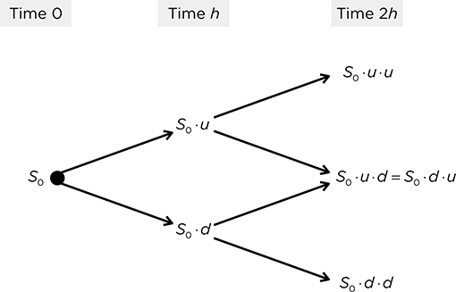

# Replicating Portfolio

* There is **NO direct method** - every component has to be calculated via recursion
* Thus, this method should **only be used** if the question specifically asks for the **replicating portfolio at an intermediate node**
* Note that the **Replicating Portfolio changes at each node** - thus, the previous replicating portfolio must be sold to buy the new one
  + Portfolio is **self-financing**– selling the current components will **exactly allow you to buy the necessary components** for the next period

ди =о.780 
виу 
sell 
до = 0.4310 
=-12.7721 
Виу 

# Risk Neutral Valuation Method

* There are now **three unique ending possibilities** - because the middle two converges into one
* Instead of recursively solving for intermediate option prices, we can **directly calculate the probability** of each of the ending nodes using the **Binomial Distribution**
* 

$$dd \rightarrow K = 0$$

$$ud \rightarrow K = 1$$

$$uu \rightarrow K = 2$$

* + 
  + 
  + 
* 

$$X \thicksim \text{Bin}(n, p)$$

$$P(X = K) = \binom{n}{K} \cdot p^K \cdot (1 – p)^{n-k}$$





* Remember the first term to **count the number of possibilities**
* The middle scenario can happen in 2 ways, while the top and bottom scenario can happen 1 way each

# American Options

* They have the option to be exercised early, thus we need to consider at each intermediate node if the Option should be **exercised immediately or held off** till later
  + **Immediate Exercise Value** → Payoff of the Option at that node
  + **Pull Back Value** → PV of future payoffs
* We compare the two values to determine what should be done
  + **Immediate Exercise Value > Pull Back Value** → Exercise Immediately
  + **Immediate Exercise Value < Pull Back Value** → Exercise in future
  + **Immediate Exercise Value = Pull Back Value** → Indifferent
* 
  + Since the value at each node is not confirmed, there is **no direct method** to calculate the Option Price in one step
  + Since an American Call *without dividends* will never be exercised early, it is identical to a European Call thus the **direct method can be used**

## Solving for Strike Prices

* There are several questions that will ask to solve for the **minimum or maximum strike** that will result in the option being exercised early
* However, the equation to solve contains a maximum function - it cannot be directly solved
* Thus, there is a need to assume **different cases** so that we can eliminate certain maximum functions

$$S_ 0 – k > e^{-rt}[p \cdot \max(K – S_u, 0)]$$







$$\max(K – S_u, 0) = K – S_U$$

$$\max(K – S_D, 0) = K – S_D$$







$$\max(K – S_U, 0) = 0$$

$$\max(K – S_D, 0) = K – S_D$$







$$\max(K – S_U , 0) = 0$$

$$\max(K – S_D, 0) = 0 $$



